CSY2027 GROUP PROJECT

GROUP 1

By

Callum Teesdale

Matthew Rea

George Robertson

Contents

Introduction 3

Comparative Study 4

Game 4

ceX 4

Interview with the Client 5

Requirements Analysis 6

Main Features 7

Preliminary Designs 8

Home Page 8

Search 9

Detailed game page 10

Checkout 10

Database 11

Implementation 12

Home page 12

View game details 13

Games 15

Cart 16

PayPal 17

Successful checkout 18

Predictive search 19

Create an account 21

Customer orders 22

Login page 23

Admin orders 24

Admin products 25

Add/Edit products 26

Testing 27

Conclusion 28

Link to Group 1 Progress Log 28

# Introduction

Northampton Gaming has requested their own website allow them to sell their products through a web-based format. The main aim for this will be to allow Northampton Gaming to have a website with their inventory listed on it to allow for postal orders to be submitted online. The client will need to be able to alter the contents of the database of the site, to add and remove products as they become available or sold, and alter the details regarding individual products, such as the price to match the in-store price should a product be discounted. The main feature will be the ability to search through the shop’s inventory online and make orders from this inventory.

The client is currently having issues with there being a lack of foot traffic through their shop, and they would like to gain a digital presence to supplement their business and sales. They would also like their entire inventory to be available online to support this change, along with the simplicity of updating each individual entity in the database when a new product becomes available or a product is no longer in their inventory.

The purpose of this application would be to allow users to quickly and easily identify the titles they would like to purchase and the ability to discover new titles. The main objective of this project is to create a platform that will allow the user to view the title they are searching for at a glance and purchase it with ease. The website also needs to inform Northampton Gaming of where to send the products purchased through the site, track who has purchased what, and an easy payment system to say when the product can be dispatched.

The project is set to be completed in early May 2019 with a timetable set t be added using Gantt style of planning for a project. This structure allows for each part of the project to fit into a time frame and focus on specific parts, which may be more demanding and time consuming. There is also a period to allow for delays.

For software, we will be using MySQL and PHP primarily to build the website and database, with HTML and CSS used for styling. This will allow the site to have access to all the products in the database and display the relevant information. The server is set through the university and can be connected to using the unique group login. With may PHP editing programs available for download we have many to choose from. We will mainly be using ATOM for this as it has a GitHub link functionality.

The data on the games will primarily come from the inventory of Northampton Gaming’s existing stock and will be updated through the admin section on the site. The reviews for the games will come from Metacritic, a trusted review site. This allows customers to get an idea of how these games have been received by the wider gaming community.

# Comparative Study

We decided to research some of the biggest game marketplaces.  These were “Game” and “CeX”, the biggest game marketplace for pc. We decided to look at 4 different areas for each site, mainly the most important parts for the user. We looked at the home page, the game page, the cart page and the general usability of the site. We felt like these pages were the most important for a user and can be the difference between a sale.

## Game

Game are the leading UK retailer for gaming and accessories. They have a huge physical presence with other 200 stores nationwide.

Home page

The home page features a huge banner right at the top with the latest game to release. Right now this features Red Dead Redemption 2, the highly anticipated game from Rockstar set to break records. This banner also rotates through other offers and deals the user may be interested in. Scrolling down, are more boxes with other information and links for the user to click on to take them around the site. The home page sticks religiously to their black and purple colour scheme, a staple for Game. The colour scheme is very easy on the eye.

Store Page

The store page can differ from game to game. An older game will have their basic layout compared to RDR 2 for example. The basic layout, however, is presented very well. The page has the box art along with other media at the side, a dropdown for a different platform or edition of the game. The page also has a good retail description of the game. The price is also out there easy to see. Nearer the bottom is a “Frequently bought together” section, common on many other sites, that Game claim to be bought together often. Further down is a more expansive information section alongside their delivery information and their two reward schemes. The page also sticks to their colour scheme nicely.

Checkout

The checkout page is simple, making sure the user has the items they want. It features an item count alongside the order total. Below that is the promo code section. The page shows the items with the PEGI rating for each one. Again, on this page, the reward scheme is featured.

Conclusion

As expected, the UK’s leading game retailer has a very good website that gets the job done efficiently. Their website is especially easy to use and does a really good job of promoting the items you'd like to see. They’re also branched out into other parts, looking like a general news site with a convenient game selling site alongside. They stick to their colour scheme which carries onto their retail store meaning the brand is very recognisable.

## ceX

ceX is a company that relies quite heavily on trade-ins for their inventory. They do get some new games, but mostly, trade-ins. They have a large physical retail presence with more than 350 stores in the UK and over 100 overseas.

Home page

ceX's home page at first glance is outdated, however, going with this method allows it to have very fast loading times, but also does pack to features underneath. The site allows you to add items to your buy or sell baskets while keeping you on the same page.

Store page

The store page carries over with this slightly outdated look, but like the home page, does have a few nice features. It has large box art for the game along the side. It provides the 3 different prices for the 3 different ways to sell or buy the game. It also gives you a postcode lookup to see if your local store has it in stock which is nice as it allows you to save time rather than wasting it by travelling there if they don't have it. They also have “games you might like” section but much like game, I feel like this is games they want to advertise rather than good recommendations. They also have a user reviews section which could convince a shopper to buy.

Cart page

The cart page features your selling and buying cart. It gives you a nice breakdown of all the different prices for each product. The cart page is very simple and to the point with not much to it.

Conclusion

Even though the website does feature an outdated look, it allows the shopping experience to be fast and smooth. There are very minimal loading times which allows the website to do its job efficiently. It gets the job done with very little bells and whistles.

However, this simple look could be underwhelming for someone wanting to just browse and get suggestions. The buyer would need to know what they were looking for before going on the site as there isn't a whole lot of information provided. In hindsight, this could turn away potentiometer buyers.

# Interview with the Client

What features are necessary for your site?

The main features we’d need for an e-commerce site is for customers to view our inventory and place orders. We also need to be able to see all these orders so we can view and send out the order to shipment. We also need to be able to update and add products to the site as new inventory comes in, in an easy to use interface.

We also need the site to be easy to use as we have a large inventory so being able to easily narrow down different products is a must for our customers.

Do you have any current branding?

We currently have a brand identity in our store with a well-known logo in the local community and a colour theme of blue and grey. We would like our current logo and the site to follow along with our in-store identity and colour theme, so our customers know it’s us.

Do you currently have a customer outreach program?

We used to send out flyers to customers who signed up to it in store but that was starting to get too expensive and wasted paper. If we could compose an email with our latest offers that customers can sign up to and send them that would be beneficial to our business.

What information do you need to fulfil an order?

We would need the customer's shipping address in order to print the shipping labels and what their order contains. We would also like to be able to have them track where their order is in our system whether payment is being processed or if it is being packed or if the order has shipped.

# Requirements Analysis

The aim of this project is to create a website that has a database of games that a user can view with a graphical frontend, and then be able to purchase their selected games. The site should be pleasing to the eye whilst being intuitive to use.

This project is for the client Northampton Gaming. We are hoping to create a website that meet their needs, for the use of their customers to make purchases and browse games and the staff when making changes to the site. This will be completed using HTML, CSS for the front end and PHP and SQL for the back end.

By May 2019, the site should be fully functional and ready for the client to launch publicly. Along the way we will set deadlines for certain features to help us keep track of where we are in the project. We will use a Gantt chart to document this progress.

Due to the timing of this project, it is running alongside current sessions where we are learning both PHP and SQL. This means that without extra research in our own time, we may not have the knowledge or skill to add some functionality we may be wanting to feature.

After the launch of the website, we are hoping to drive traffic to the Northampton Gaming website and increase their sales by a substantial amount.

The deadline for the project is May 2019, at which point the website needs to be ready to launch. Within 6 months of the launch we hope to increase Northampton Gaming’s sales by 50% while also needing less man hours needed to maintain the website

These goals would be complete if the client is happy with our work and launches the website in May 2019. We need a functional backend with a visually appealing front end and smooth user experience. The new updated website is wanted to increase the traffic to Northampton Gaming and hopes to capitalise on that traffic and increase their sales by 50% while using less man power on maintaining the site, resulting in increased profits.

## Main Features

|  |  |
| --- | --- |
| **Feature** | **Purpose** |
| Homepage | * Give a brief overview of the site * Display games with larger art * Adverts for games * Navigate to other areas of the site |
| All games Page | * Display all games in a list * Search games * Sort games by: * - Price * - Platform * - Tag * - Rating * To show a brief description * To show game art |
| Per game page | * A gallery of game art * Game trailer * An in-depth description of the game * Age rating * Select the platform version * Select the game version * Reviews from users * Add to the user cart |
| Cart page | * View their cart * Edit their cart * - Delete items * - Change the number of items * Checkout |
| Checkout | * Checkout with PayPal |
| Help Page | * FAQs * Contact staff |
| Account page | * View orders * View reviews * Edit account * Delete account |

# Preliminary Designs

## Home Page

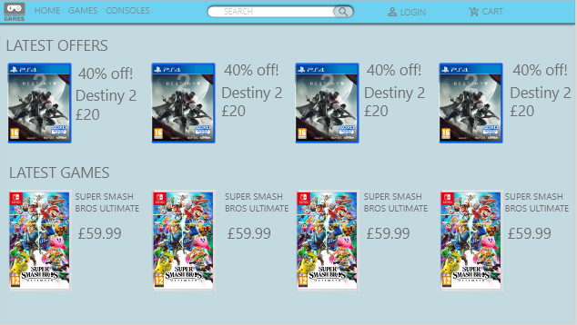

This is the home page of the site. It will feature a banner ad of the latest game and feature the 3 top selling games. The secondary nav will be a quick way for the user to filter a search without having to specifically search for a single item.

## Search

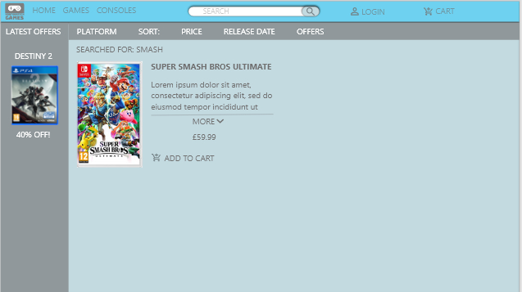

Once a search is initiated the user is taken to this page where it lists all relevant results. The side nav allows the user to narrow their search criteria by age, platform and any relevant tags.

If a user hovers over a game, they are shown a brief description of the item they have hovered over.

## Detailed game page

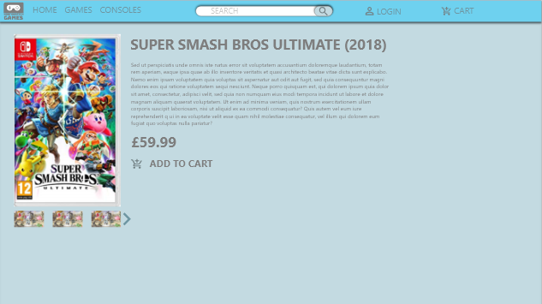

The detailed game page shows the user a greater view of a selected item. It has the main boxart and a gallery below with screenshots and a trailer if there is one. It has a larger more in-depth description and an area for offers like if the game has multiple editions or other related items. The user then can add to cart.

## Checkout

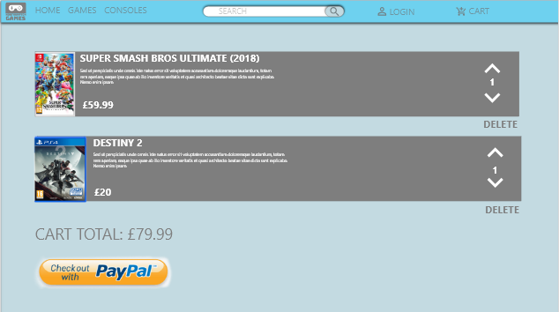

The checkout page shows the user cart in a single list, where they can change the count of the same item or delete the item. This also shows a picture of the item and the brief description to ensure the user knows what is in their cart. They can then checkout with PayPal.

## Database

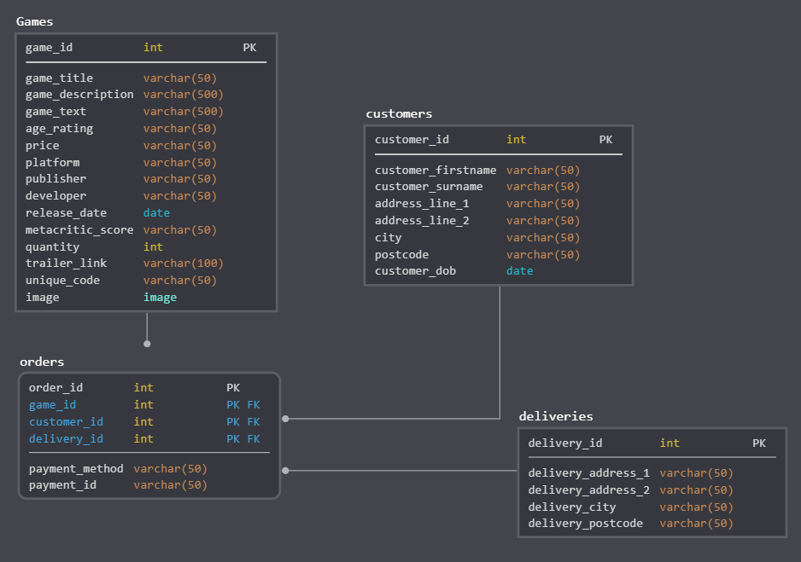

This is the design image for Northampton Gaming. They are looking for a database system to move away from their paper-based system for stock keeping. The database features 4 tables ‘games’, ‘orders’, ‘deliveries’ and ‘customers’. The ‘games’ table is where the website will pull the information from to show on the website. It has all the columns needed for the page with some, such as the PEGI rating, allowed to be empty.

The orders table will use the game id and customer id from the games and customers table respectively. This will help the deliveries table keep track and allow the staff to look at orders placed and search through them. This deliveries table will be on a GUI to allow the user to access them easily.

The customer's table will keep the customers details for orders. This table, as mentioned above is linked to the orders table to allow for easy access.

# Implementation

## Home page

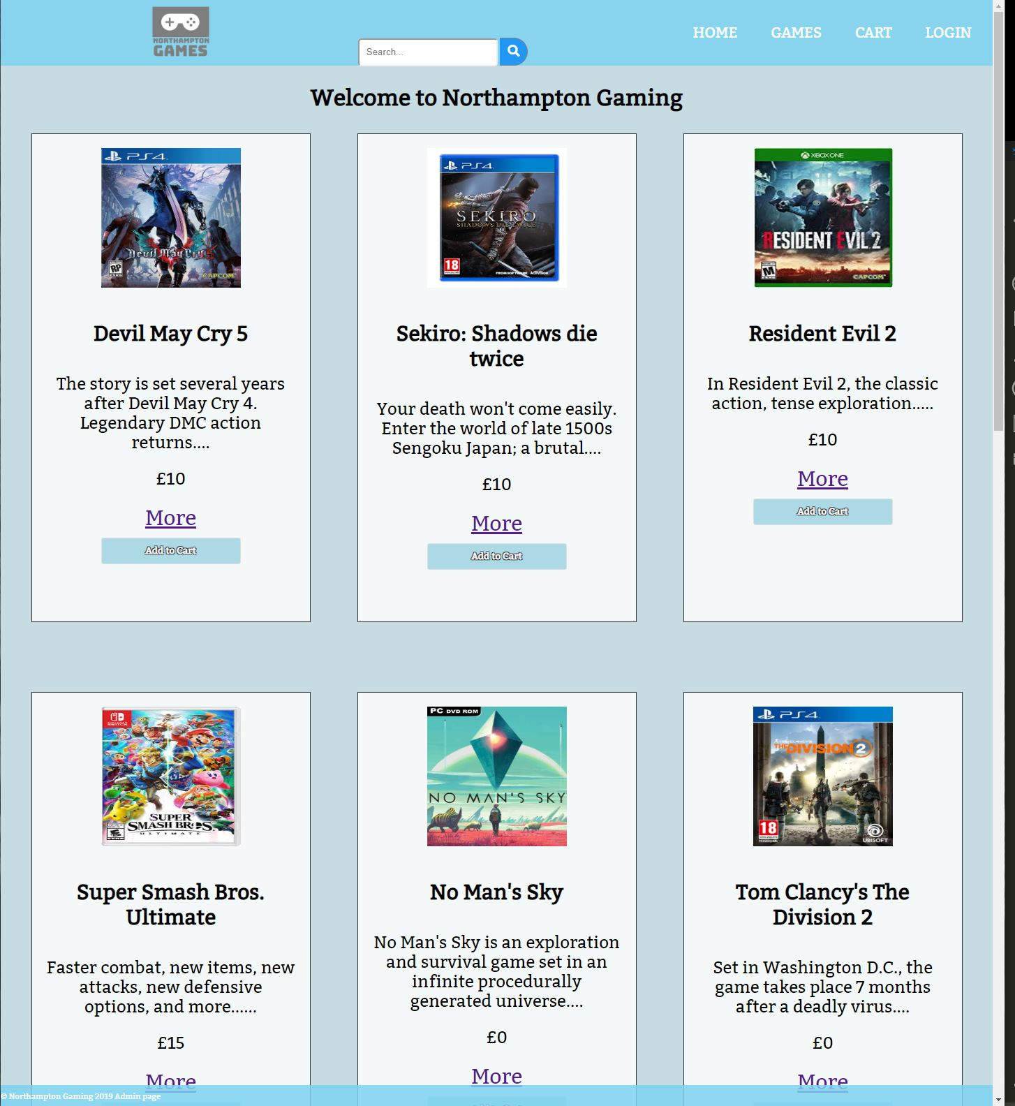

This is the home page, showing the entire inventory available. This page is also unsorted. The individual games are shown in a card format, in a kind of display window format. The more link takes you to a different page based on which game the link is from. This then shows the extra information hidden when it is in this state. The add to cart button adds the product to the cart list and can be viewed when pressing the cart button in the top right.

## View game details

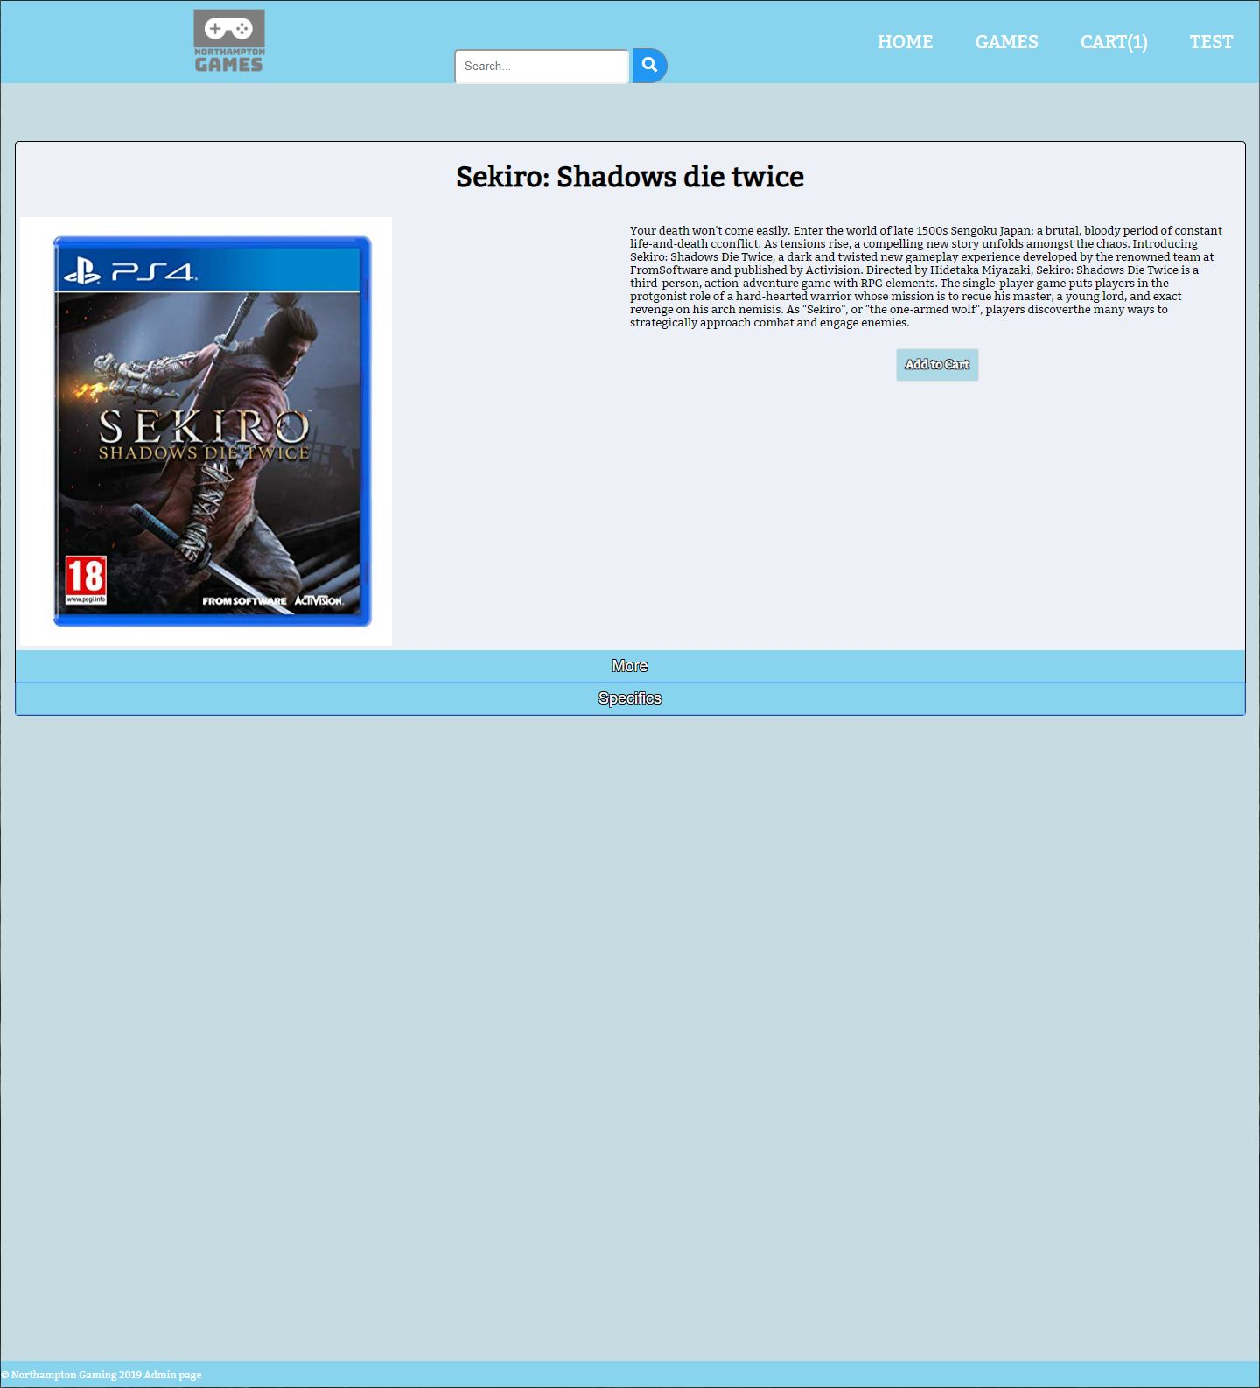

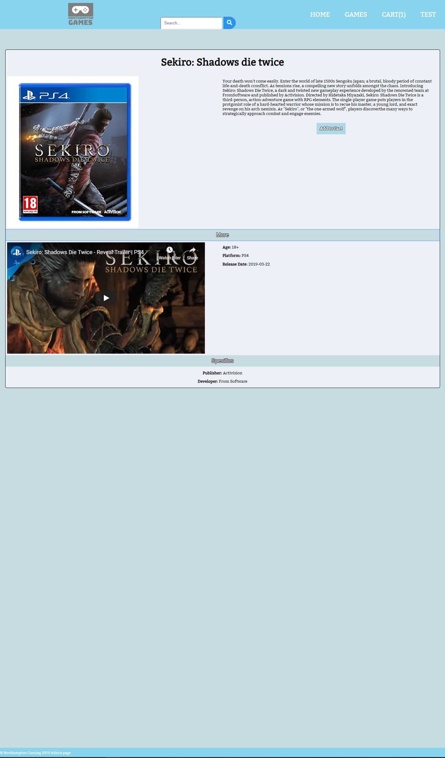

This is the page that displays when the “More” link is pressed on a game. The first image shows the standard display, with the second image showing the hidden information below in the “more” and “specifics” tabs. The add to cart button does the same as previously mentioned. All key information on each title is shown on this page, including a YouTube trailer for the game, where available.

## Games

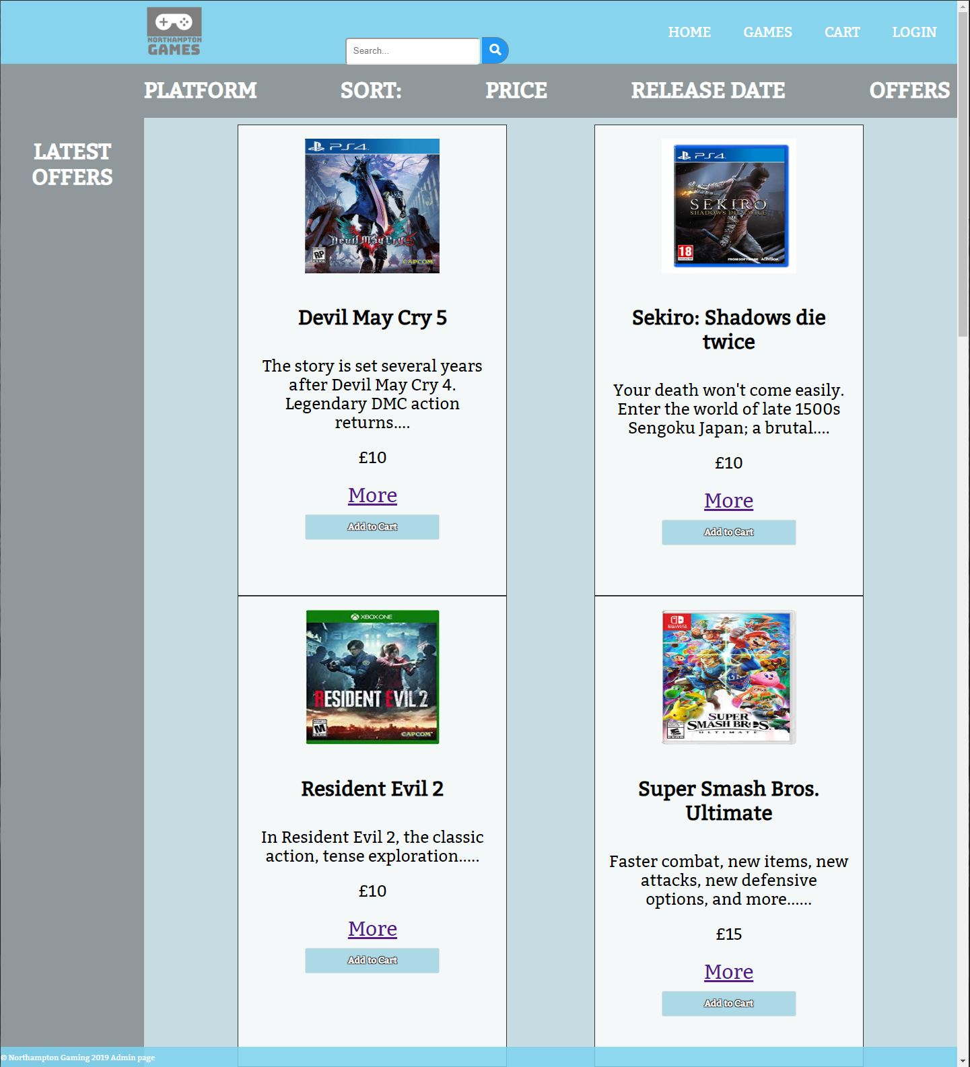

This is the games tab in the top bar. This tab allows for search via x, based on which option is selected at the top of the page.

## Cart

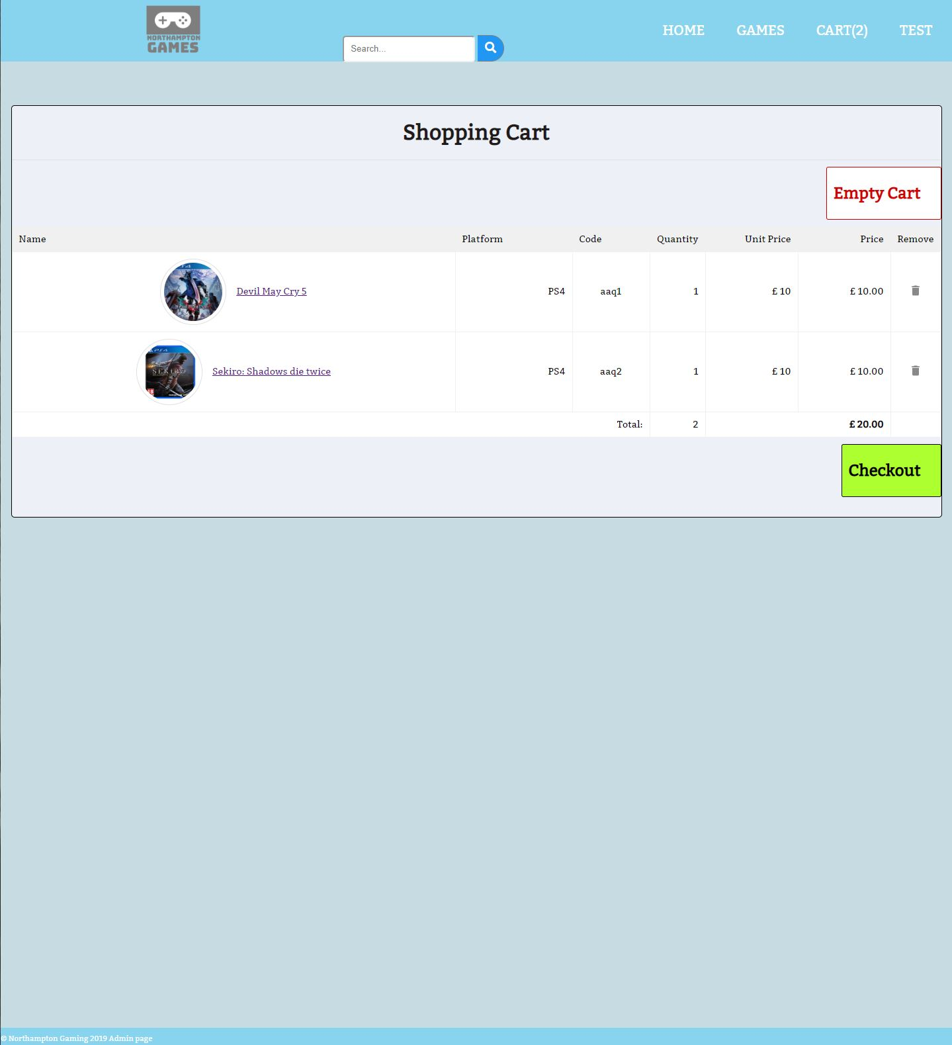

This is the cart page, shown when the cart tab is clicked. The tab also displays the number of items in the cart at the top right when on other pages with items in the cart. On this page there are options to remove items from the cart, empty the cart completely and proceed to checkout and order the items. The items totals are also added up, including price and quantity.

## PayPal

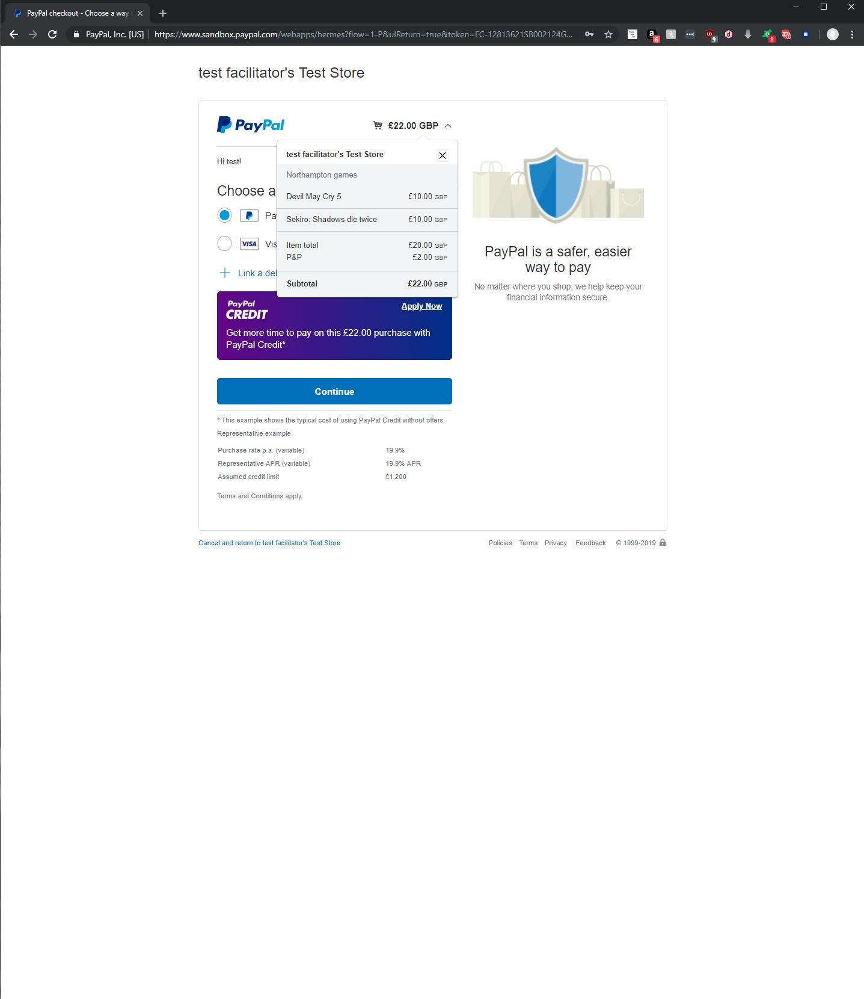

This is the payment page, using PayPal. This allows the buyer to sign in, pay for their items, without needing to save them to the website itself.

## Successful checkout

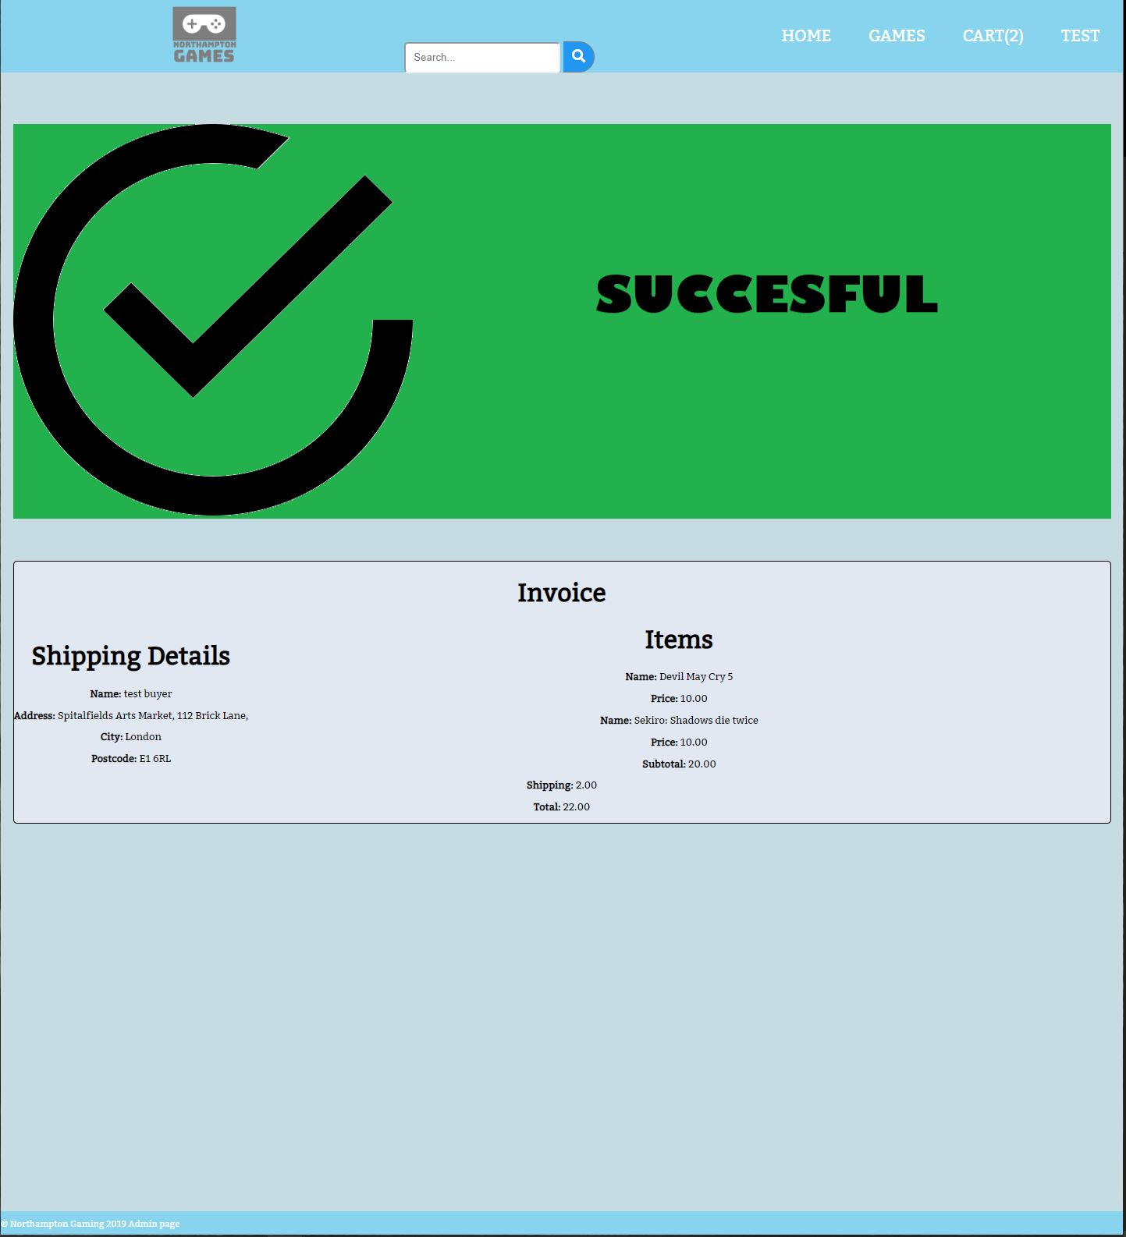

This page shows that purchase has succeeded. The game details are shown, including individual purchase. The costs breakdown for each game on the right, and the shipping details on the left.

## Predictive search

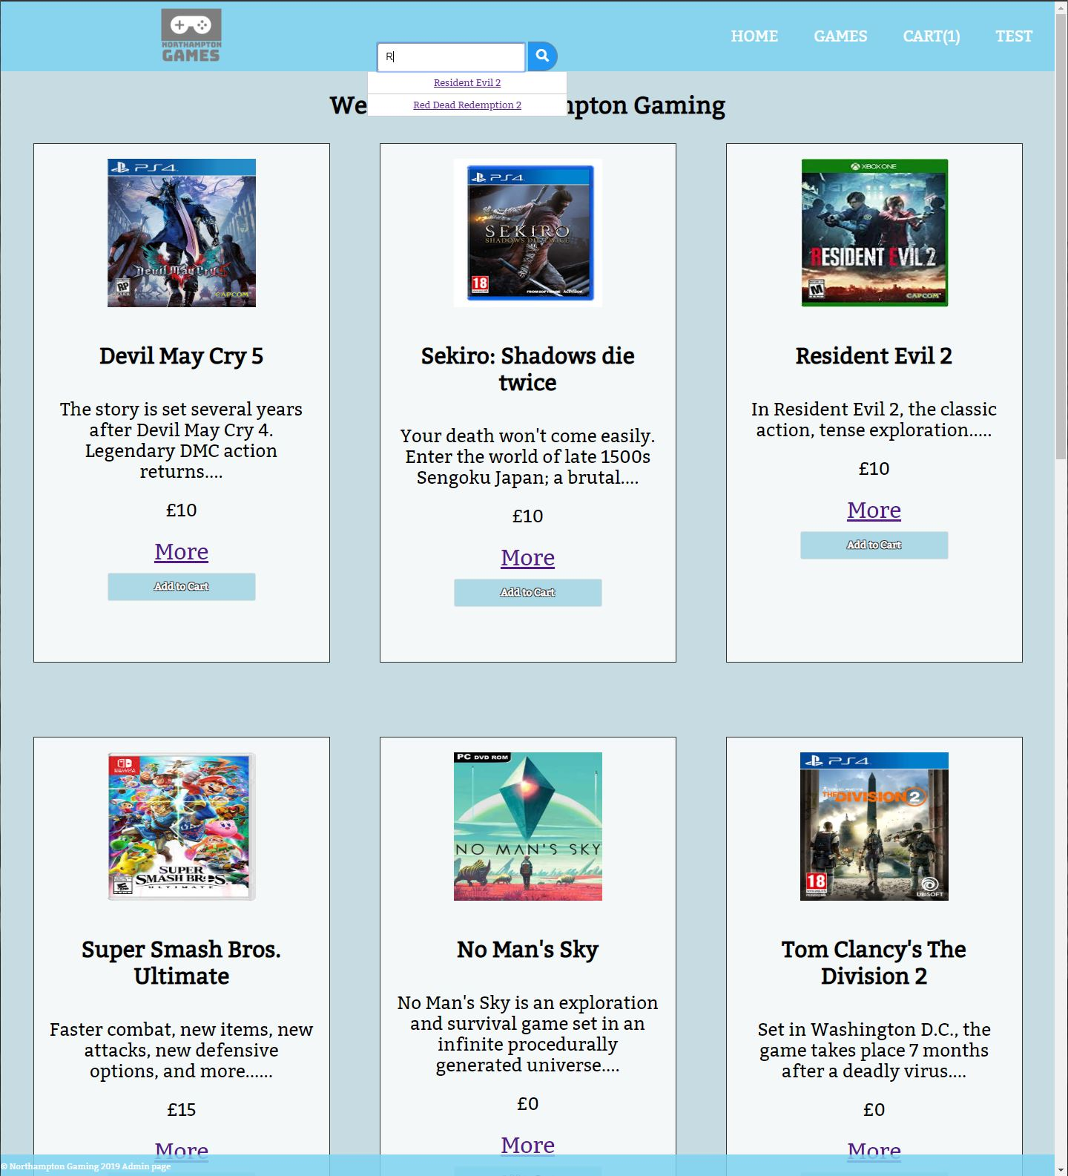

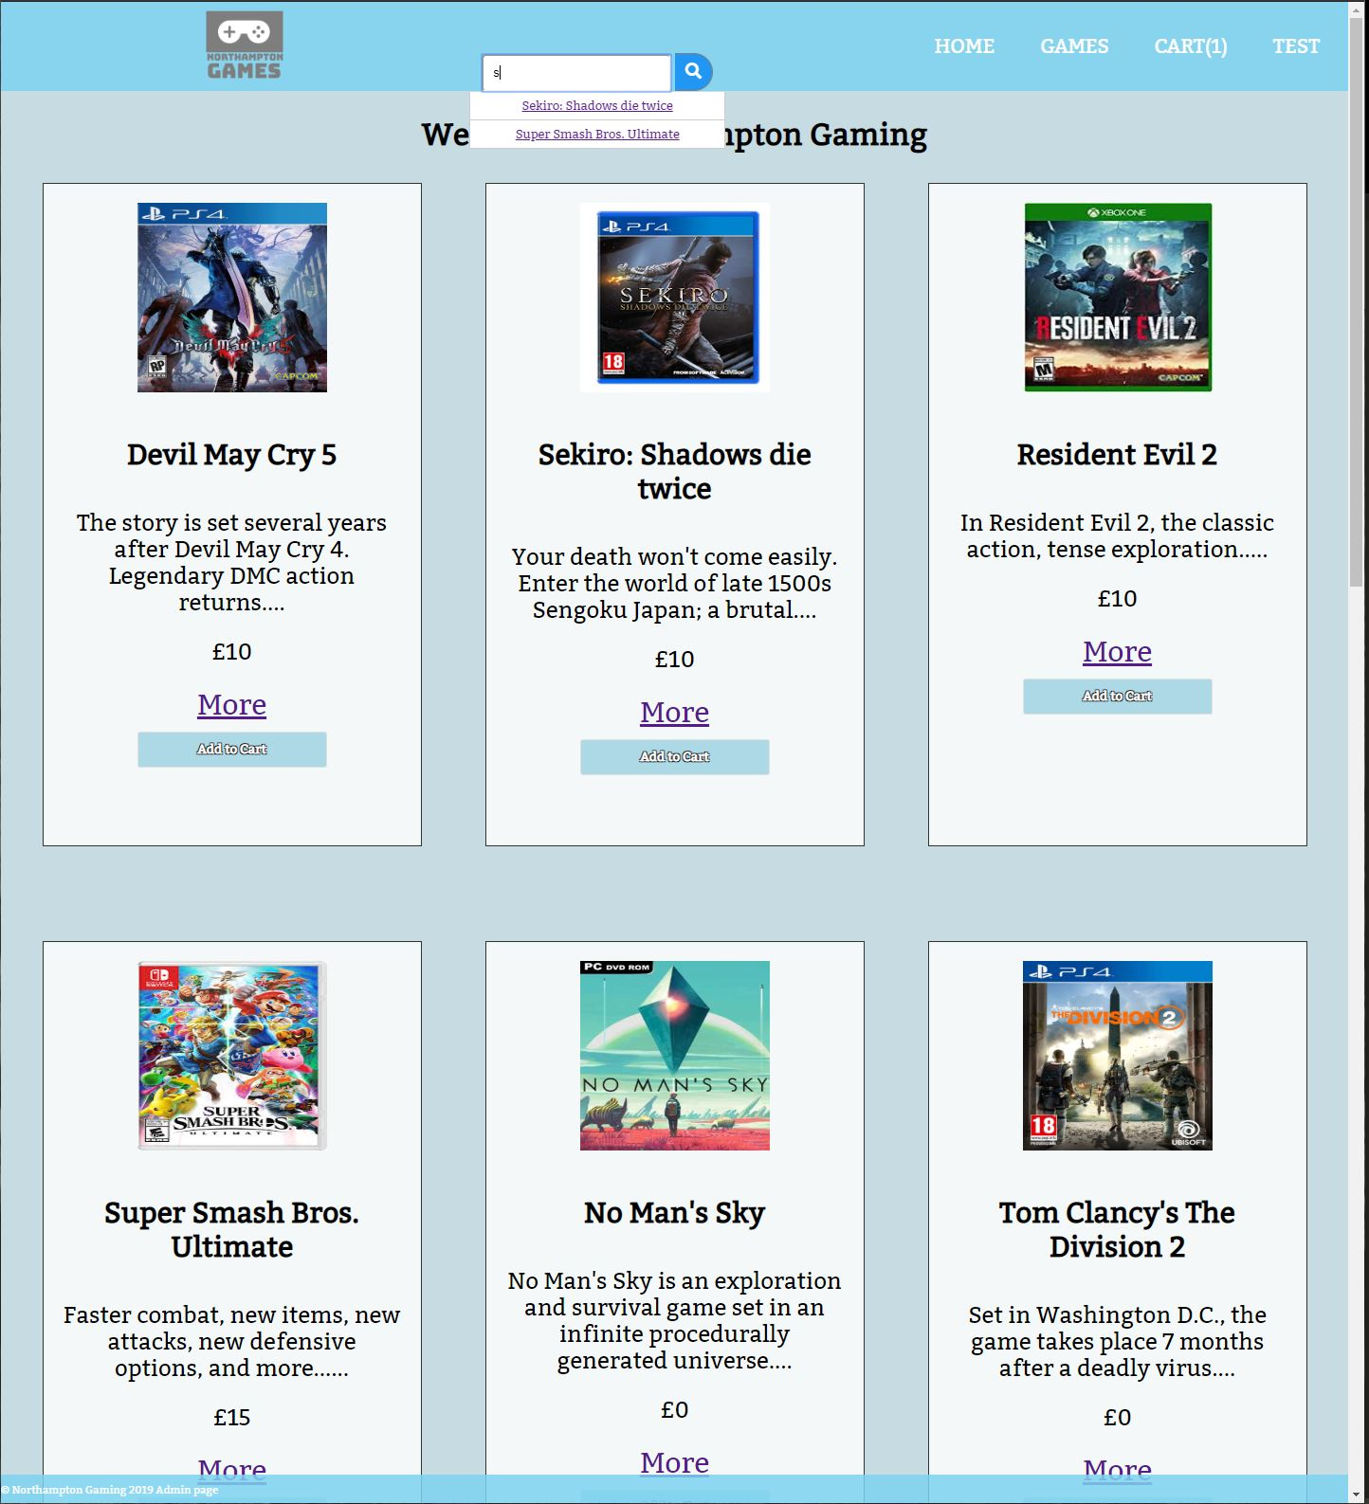

These images show the predictive search function. When anything is typed into the search bar, if there exists a game with the same first letter, or the typed in name is in the database then the search bar provides an auto fill link to the game in question.

## Create an account

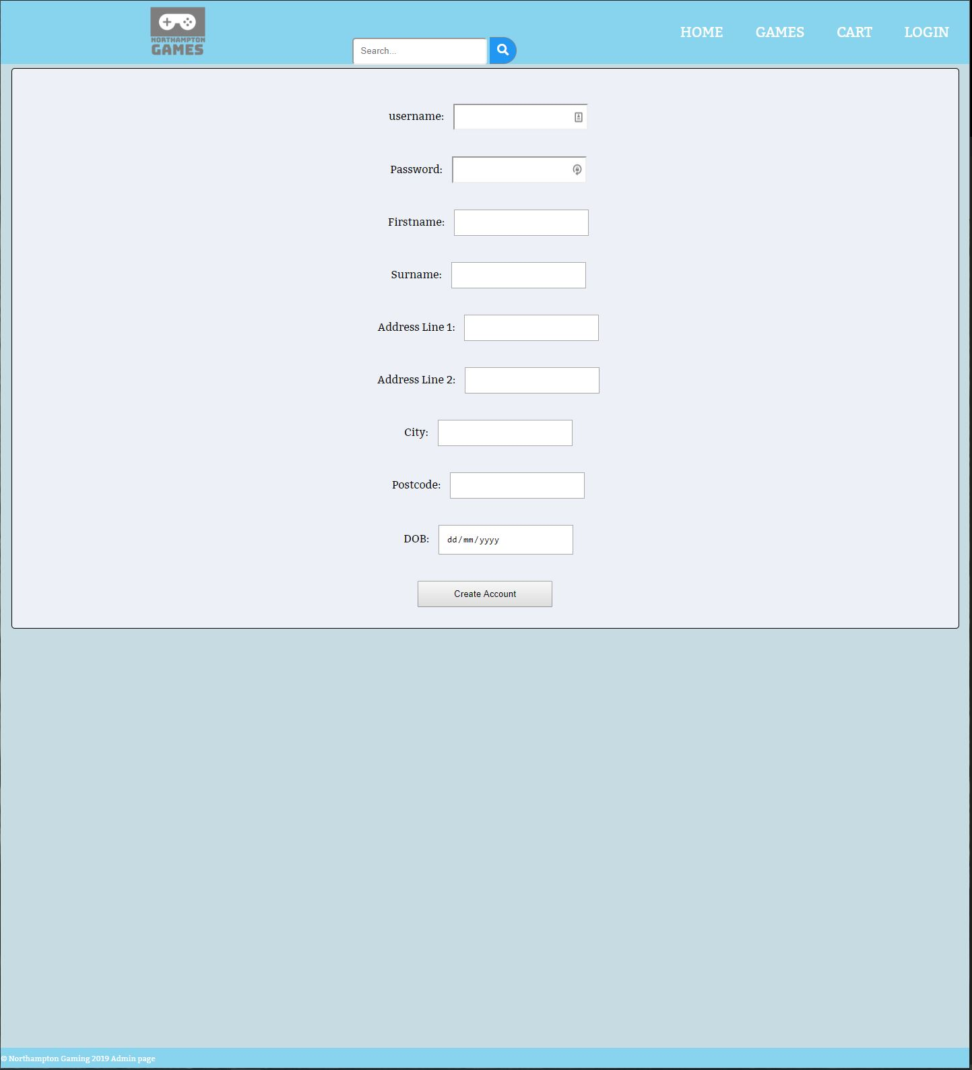

This is the create account page. All the info here is required to create an account so all form fields are required. The address entered here is used for the shipping address when an order is placed. Only the username and password will be used when logging in, the rest of the info is needed for orders.

## Customer orders

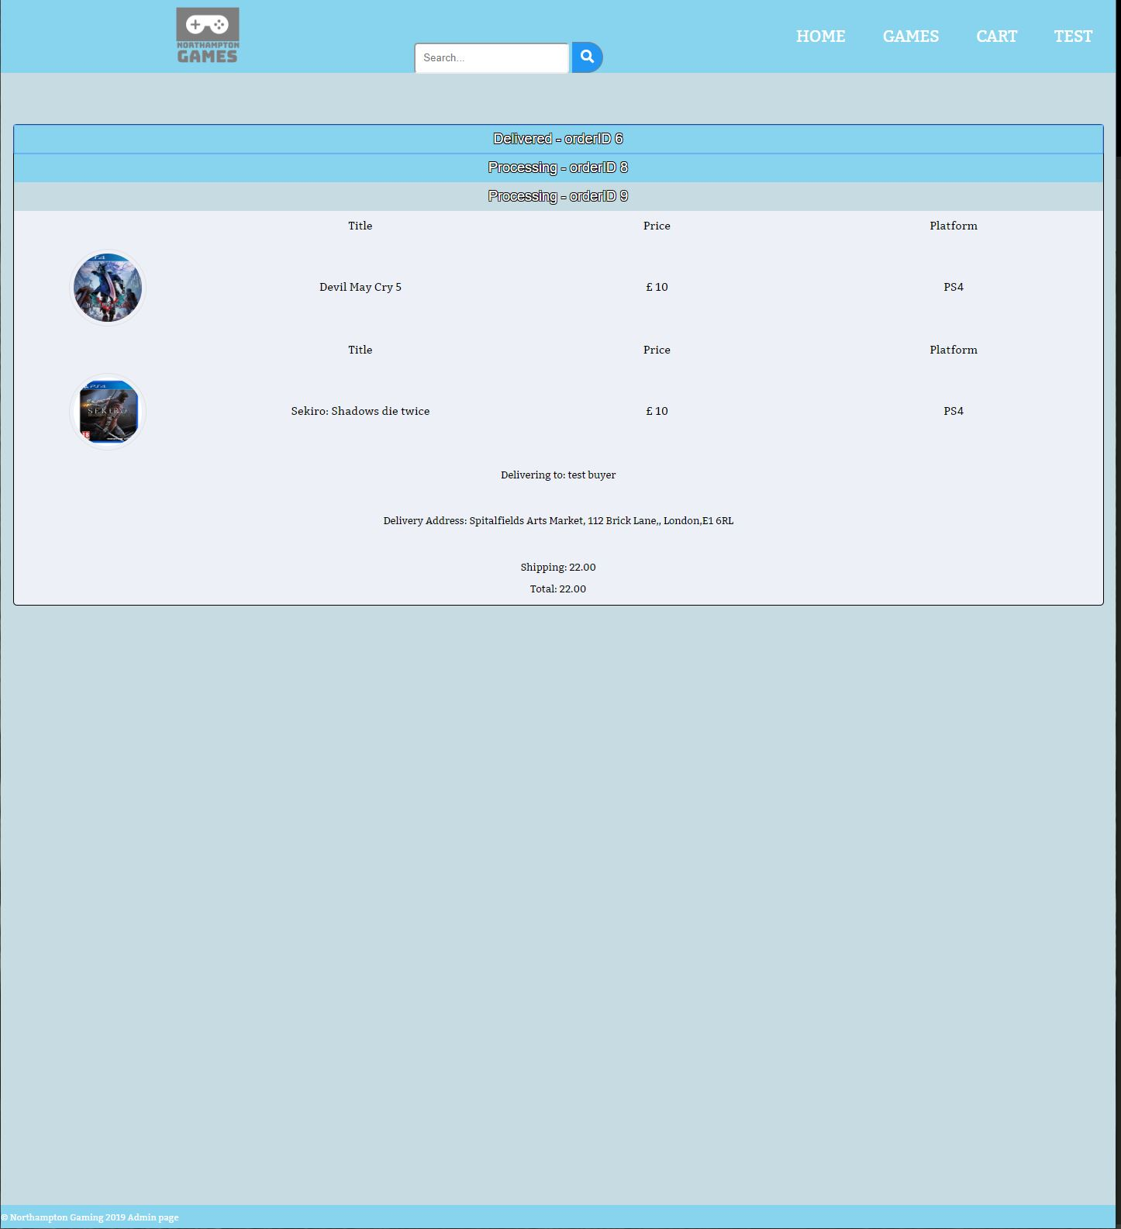

This is the orders page, viewable when logged into an account with orders placed. The tabs will increase when an order is placed, and each individual order is shown in its own tab, including the title, price and platform. Alongside the delivery address, name and total costs. Each tab’s heading shows the status of the order, switching between processing, out for delivery and delivered.

## Login page

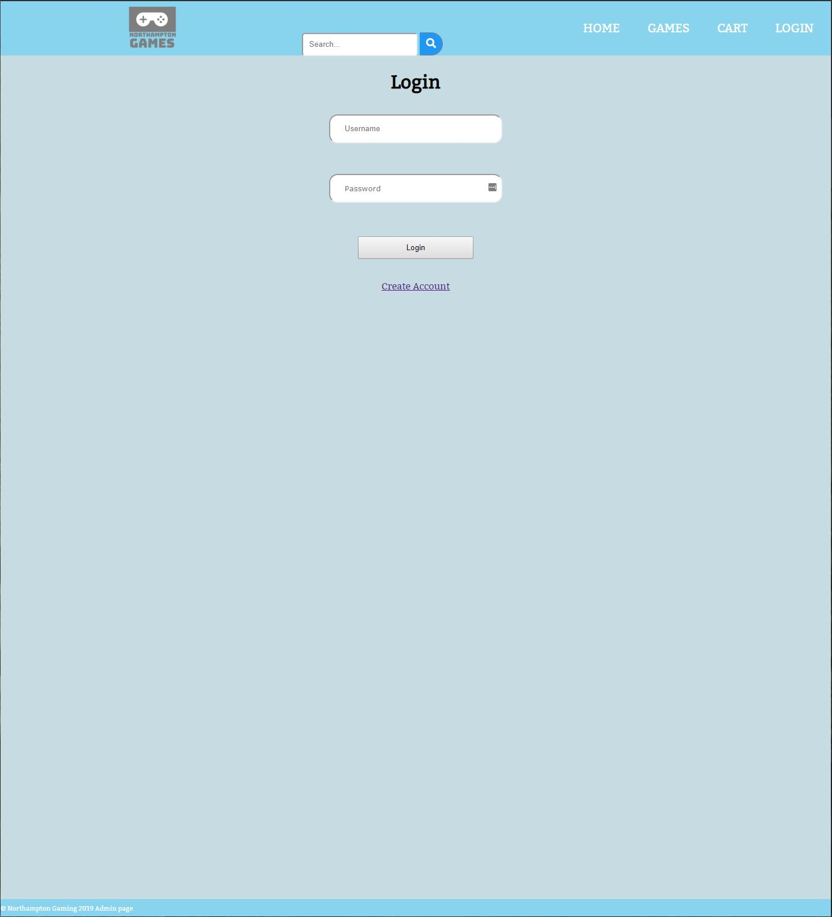

This page is for both the customers and admin to login. The page displayed for them is different based on which type of account is signed in.

## Admin orders

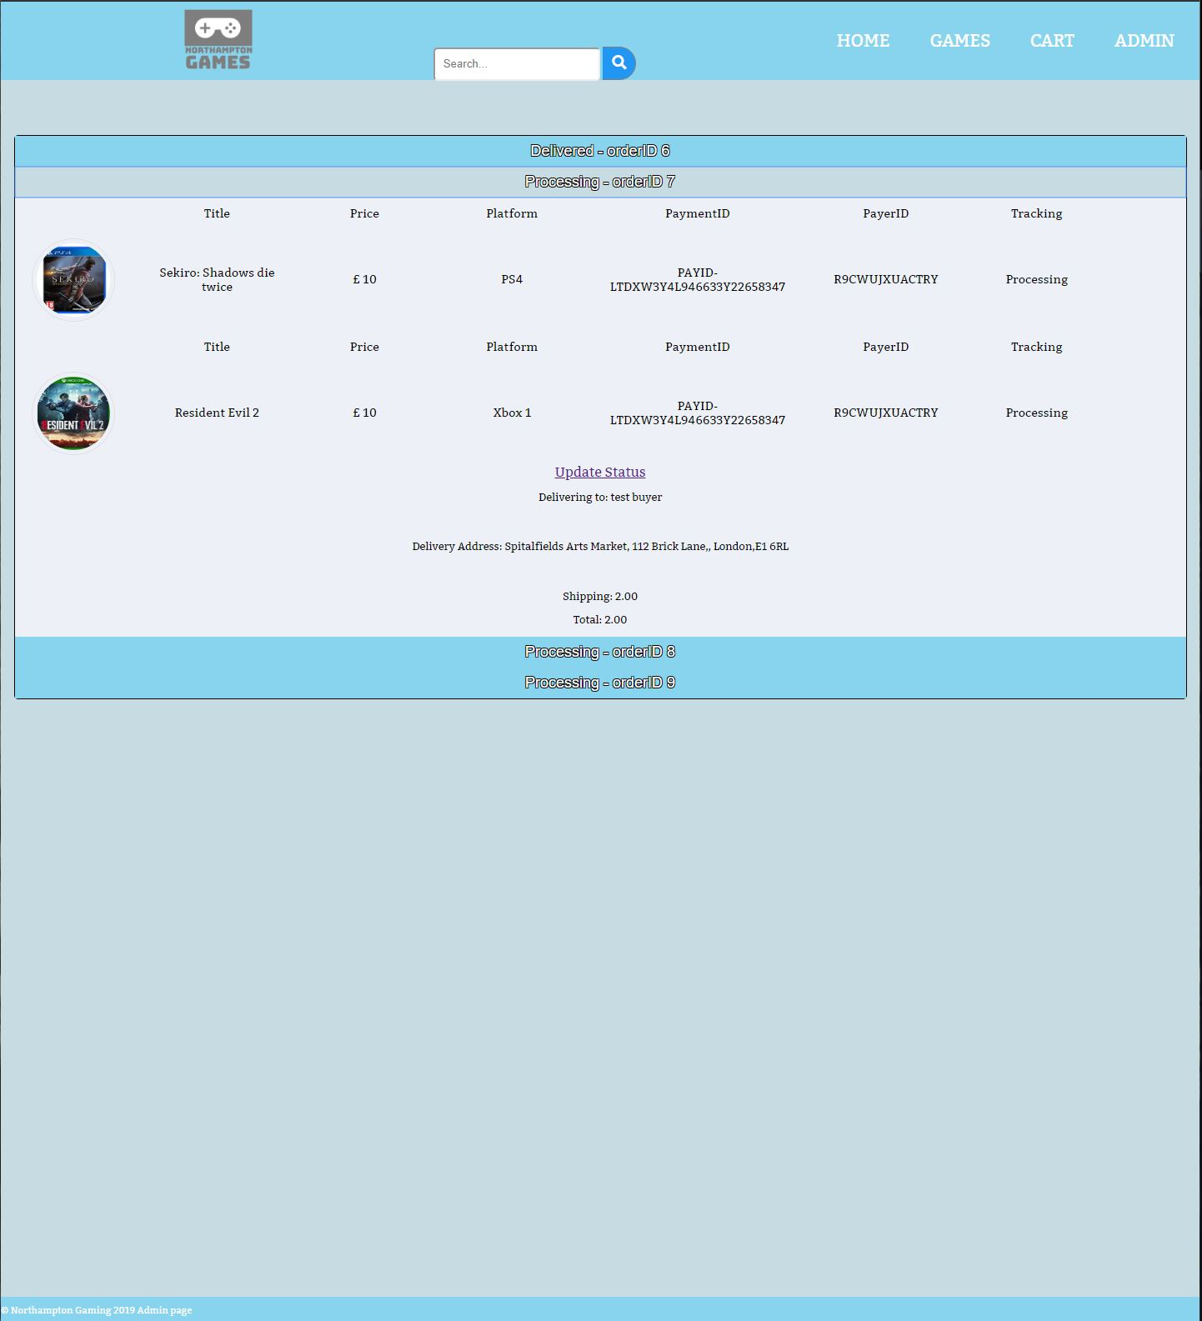

This is the admin orders page. This shows each order received for the admin to update the status of based on what has happened with it. When the update status link is clicked, the option can be changed between processing, delivered and out for delivery.

## Admin products

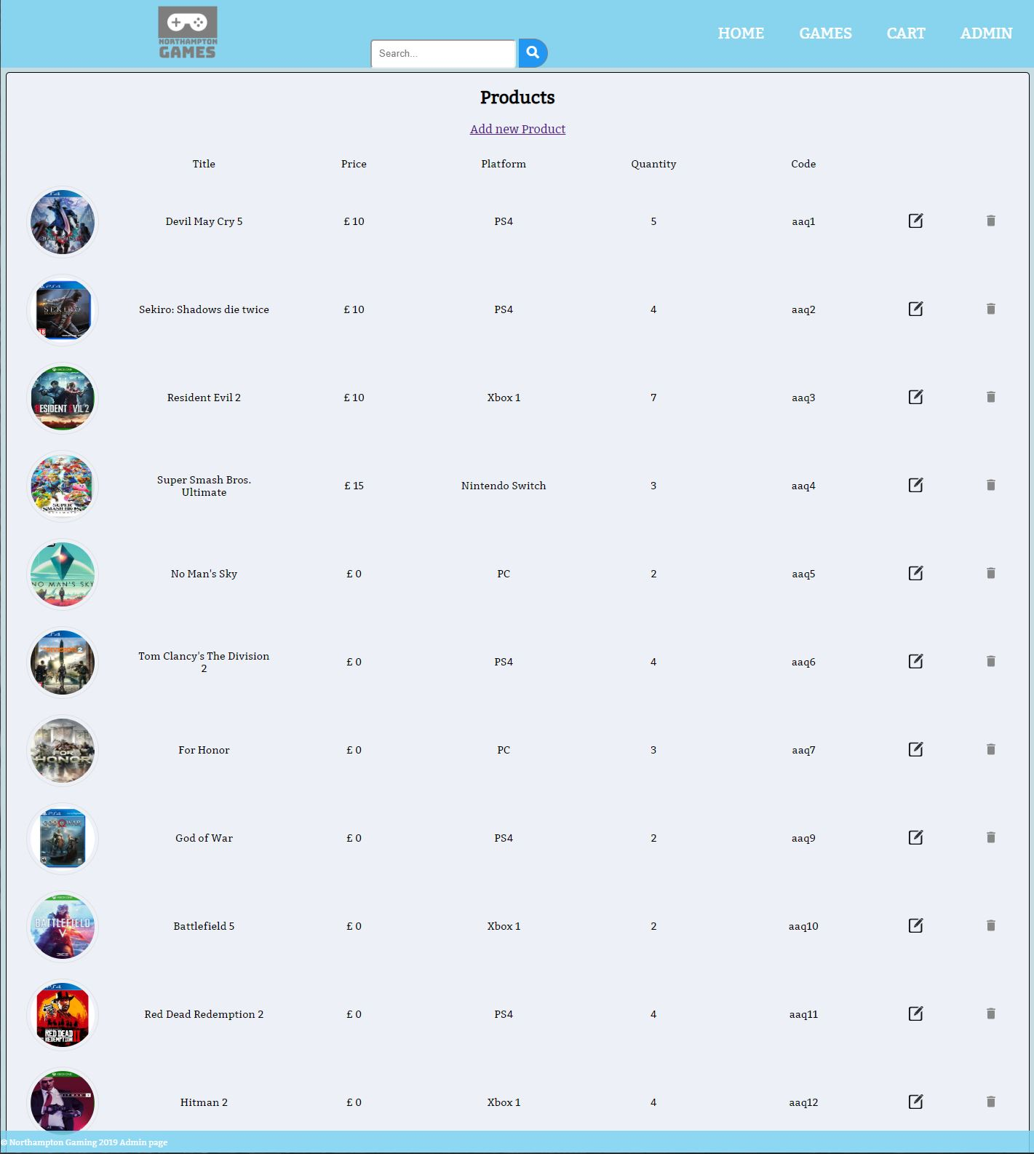

This page shows all the products available on the site. Each product can be edited or deleted, and there is a add new product link which sends you to the page below.

## Add/Edit products

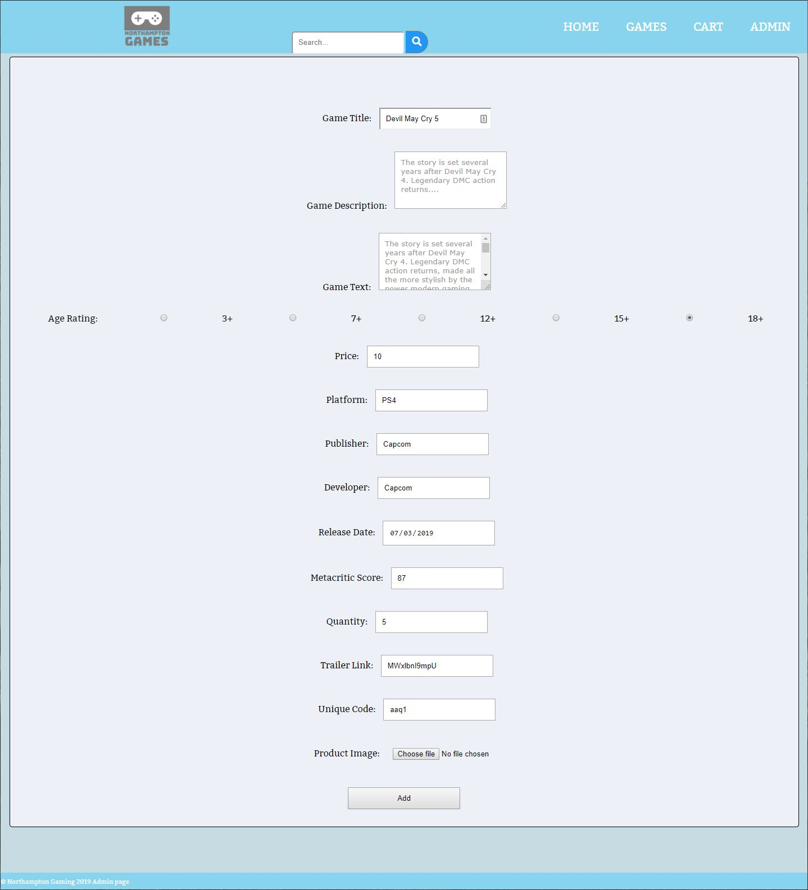

This page is similar based on which of the links is pressed. The fields have existing data in them in this one as this is the edit page. The add page would be lacking the existing data. An image file can be added at the bottom and will preside as the games image. This would normally be the games cover art or box art.

# Testing

|  |  |  |
| --- | --- | --- |
| Test | Process | Outcome and changes |
| Login system | Admin-Admin entered into login field | Admin area shown |
| ^^ | Test-Test entered into login field | Customer area shown |
| Add product to database | Fill in all fields other than product name | Product not added due to missing field. Site displays the error message and sends you back to previous page |
| Add product to database with all fields | Fill in all fields and add product | Product added. Appears in games list and in sql database |
| Search function | Entering the first letter of a title with the letter being shared by multiple titles to see if they are both shown  (letter “S” entered) | Both super smash and sekiro are shown in the drop down of the search bar |
| Add to cart on all pages | Button pressed, on an individual game. | Cart button in the top right gains (1). Additional clicks increase the number |
| Removing products from the cart page using the remove button | Multiple items in the cart, one clicked to remove | Item removed successfully |
| Create an account | Create account fields filled in with a new customers information | Account created |
| Trying to login with newly created account | Entered username and password | Login successful |
| Trying to order products with new account | Added an item to cart, trying to pay for items | Delivery address set by created account, payment successful, order created |
| Checking in admin section to see if new order has been added | Logged into admin section. Checking | New order available for review |
| Changing orders status | In admin orders section. Update order clicked | Order dropdown menu displayed. Order status changed |
| Checking user account orders for changes | Logged back into new user. Going to orders section | Order has changed to processing to out for delivery |
| Editing products as admin (changing the price of a game) | Accessed add/edit product page in the admin section. | Add/Edit page fields already filled with data from the previous product. Price updated |

# Conclusion

To conclude, this project is a culmination of multiple modules, with databases, php and PayPal integration, along with being a group project and warranting a schedule to complete the project on time. This project was started back in September and some changes have been made to the original plan. The database has gone through a few iterations with some fields being added and removed. With the php and html mix being present for website, require statements play a key role in it. With call ups of html forms and other php code, that are used across multiple pages.

For future works we would improve on the categorising system for the product. A basis for this could be to add genre tags to them and allow them to be searched by as such. Alternatively, altering the database to display the games along with their available consoles on one page and allow a selection of the console/platform in this section.

## Link to Group 1 Progress Log

<https://docs.google.com/document/d/1kWlHgfNps7C5dFkkj7nQa5956-GTfFZNqg_bwaHZH50/edit?ts=5bbddcda>